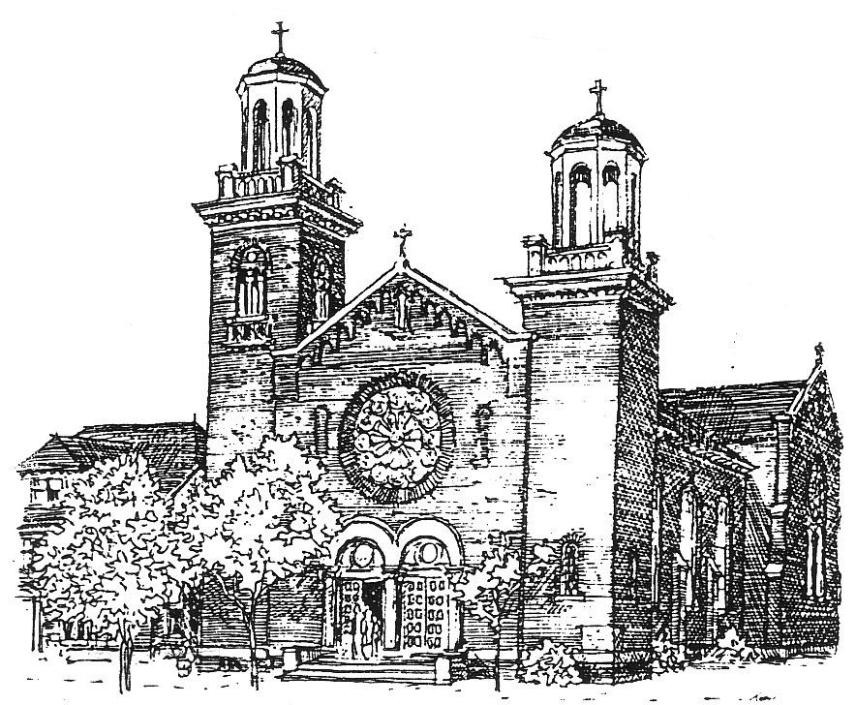

**535 8th Street East**

**Saskatoon, Saskatchewan**

**S7H 0P9**

SAINT JOSEPH’S PARISH

[www.stjosephsaskatoon.ca](http://www.stjosephsaskatoon.ca/)

Phone: 244-1556 Fax: 242-8916 E-mail: stjosephparish@sasktel.net

**Registration for Sacramental Prep**

Year: 20……. – 20……

🙞✞🙜

First Reconciliation: **First** Eucharist:

[Please print clearly]

Child's name: ___ _________ __________ _

First name Middle Surname

Age: _____________________ Date of Birth: ________________

School: ____ Grade:_________________

Mother's name: ____ Religious Denomination:

First name Maiden name

Father's name:________________ Religious Denomination:

First name Surname

Address:___ Postal Code:____

Phone: H:___ W:________ C:_________

Email:_____

Child's Parish of Baptism:_________ City/Province:_____

Date of Baptism (DD/MMM/YYY):_________________________________

Are you registered at St. Joseph Parish Saskatoon? Yes_______ No__________

If no, present parish:____________________________________________________________________

A copy of your child's Baptism certificate is required at the first class.

Fees for materials can also be paid at the first class.

***************************************************************************************

Office use only:

Baptism cert recd____________ Fee paid (cheque or cash) _________ Book received_____